Bouncy Balls

Subject: Chemistry,Elasticy,Polymers  Related Subjects: | Grade Level(s): 3rd-5th  Length of Lesson: | Type: Inquiry / Design / Project  Keywords:mixture, cross-link, elasticity, molecule

Lesson Overview
This activity demonstrates a chemical reaction primarily between the borax and the glue. The borax acts as a cross-link to the polymer molecules in the glue – basically it creates chains of molecules that stay together when you pick them up. The cornstarch helps to bind the molecules together so that they hold their shape better.

Lesson Focus
What is the central question or phenomenon being investigated? What problem are they trying to solve?

Lesson Objective(s) | By the end of this lesson, students will…  - learn about polymer formation and properties of elasticity.

Lesson Timing

5 minutes | Introduce the Lesson
30 minutes | ...

Materials | - Material 1 (# per student, per group of # students, per class)
Instructor Prep | - Step 1
Related Resources | - List related lessons/ppts etc available from USC or outside, trusted orgs

Lesson Plan

Introduction
Introduce students to the learning goals and make connections to past and present learning experiences. Stimulate interest and prompt students to identify their own questions about the topic. This can link the lesson to real world examples, introduce associated STEM careers, and assess their prior knowledge on the topic.

- Step 1

Procedure
List the steps of the activity. Remember to focus on leading students to the solution, rather than just telling them what to do. Include pictures of steps if you have them. Be sure to include some steps for discussion and reflection.

- Step 1

Wrap-up
End the lesson with some final discussions about what students designed/discovered. Connect their activity back to the focus question/problem, real world examples, and STEM careers.

Also include notes about any special cleanup considerations

Lesson Background for Teachers

Suggested Real-World STEM Connections

Role Model in STEM

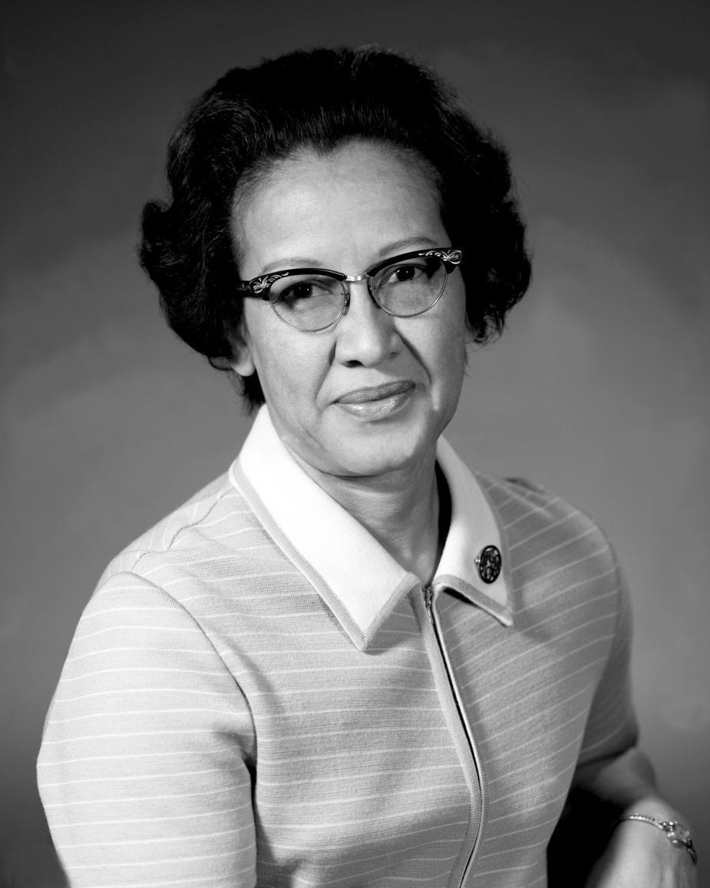
Name: Katherine Johnson
Years: 1918 - present
Quick Facts
- She is a physicist and mathematician
- The new movie Hidden Figures is based off her
- She was awarded Presidential Medal of Freedom
- She made contributions to the United States’ aeronautics and space programs with digital electronic computers at NASA
- Her calculations helped synch Project Apollo’s Lunar Lander with the moon-orbiting Command and Service Module.

Source(s):
- https://en.wikipedia.org/wiki/Katherine_Johnson
- https://www.nasa.gov/content/katherine-johnson-biography

Lesson Variations and Options
Include descriptions of alternative methods or ways to present things.

Explanation
Describe the background concepts and explanations behind the lesson. This can be more in depth than a teacher/instructor would actually share with students.

Key Concepts and Vocabulary
- Word 1: Grade Appropriate Definition
- Word 2: Grade Appropriate Definition

Safety Notes
- Safety instruction

